# C++ Shapes by nested loop second day:

Task 01:

Task 02:

Task 03:

Task 04:

Task 05:

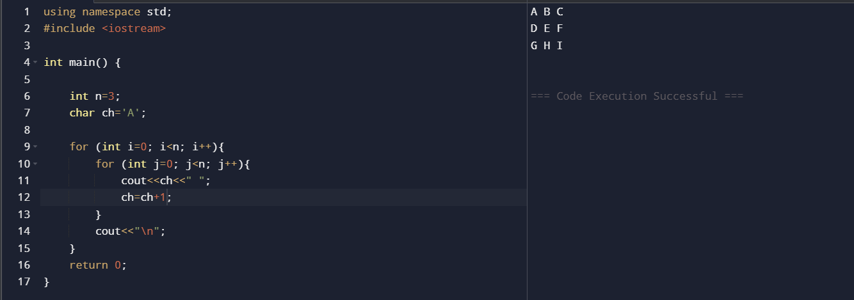

Task 06:

Task 07:

Task 08:

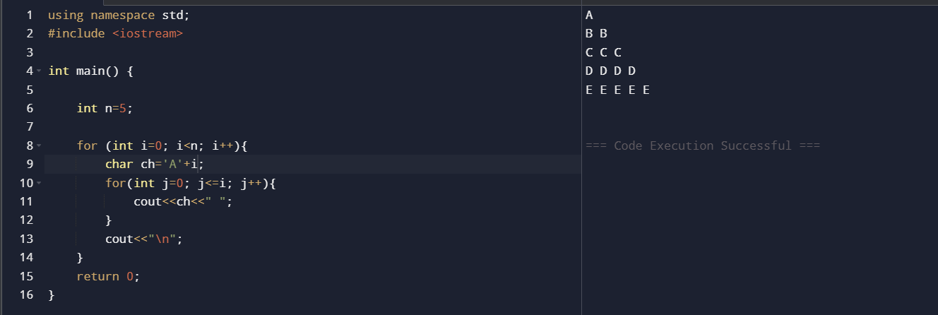

Task 09:

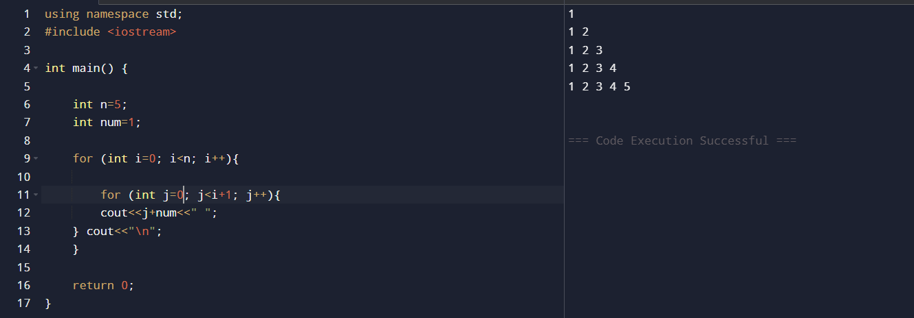

Task 10: